20/03/2020

Dear parents
I am writing to confirm the arrangement for your son or daughter to attend school from Monday 23rd March 2020.
The government has asked all schools to provide care for children of key groups including those of key workers in order to help them remain in work during this period of need. Key workers include those who work in the following sectors:
• Health and social care
• Education and childcare
• Key public services
• Local and national government
• Food and other necessary goods
• Public safety and national security
• Transport
• Utilities, communication and financial services

To support you in this we will continue to provide a bus service for every student that needs it; please see the attached letter for stops and time.
Please ensure that students are at the stops at least 10 minutes before the stated time to allow for changes in traffic.
We are running one bus to cover all stops and to allow for this the school day will now start at 8.45
Students are expected to wear school uniform.
All students attending school will have access to the same lesson work and resources as those at home but will be supervised and supported in a classroom setting. In addition we will be able to provide Sport, Yoga and Art lessons in a practical setting. Catering facilities will still be available during the school closure, and those not in receipt of free school meals will need to ensure there are sufficient funds to cover lunches.
Although there is no expectation to attend every day, we ask that you inform us if your son or daughter won’t be in school to so we can be secure in our duty of care. If we do not hear from you we will still call home.
Our wish is to provide a secure and consistent learning experience in these changing times and we thank you for your support and patience as we adapt our planning. I thank you in advance for your understanding in the coming weeks. If you have any queries please do not hesitate to contact us.

Kind regards
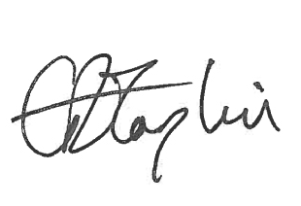
Emma Taplin

