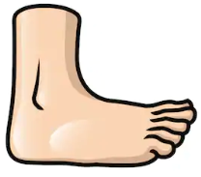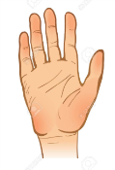**Measuring:**

|  |  |  |
| --- | --- | --- |
| **table** |  |  |
|  |  |  |
|  |  |  |
|  |  |  |
|  |  |  |
|  |  |  |
|  |  |  |
|  |  |  |