Year 2 3D Shapes Learning 25.3.2020
Please use the information below to five write sentences to compare two different 3D shapes. Use the key words of vertices, faces and edges in your sentences. For example, a cone has one edge and one vertex but a cuboid has 12 edges and eight vertices.
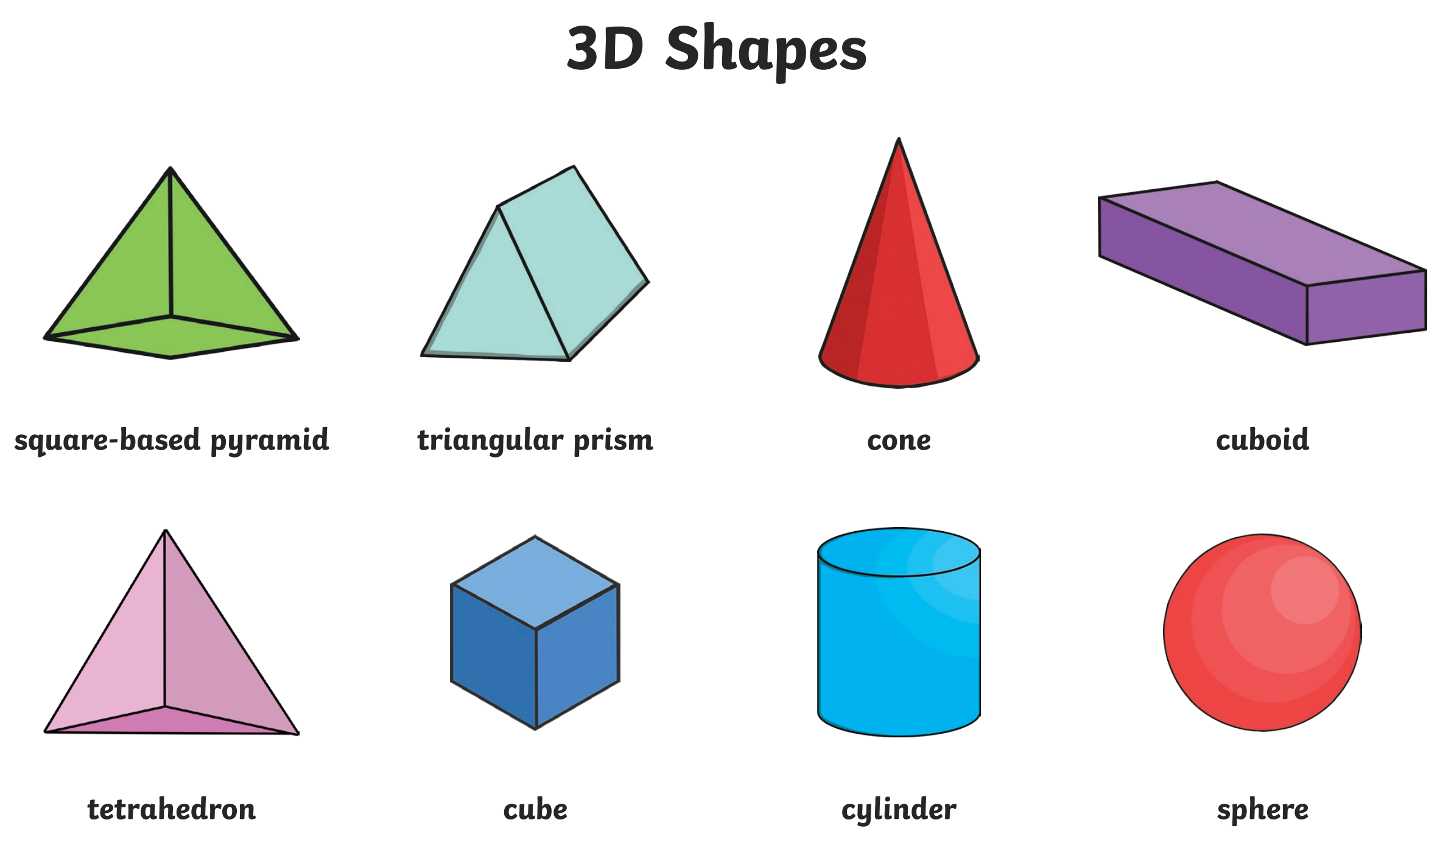
Write your sentences here:

