Year 2 Maths Day 5 - Time (5-minute intervals) 1.5.2020
You can write the answers below. If your parents find it easier, they can print out these sheets and upload them on Google Classroom, when you have finished.
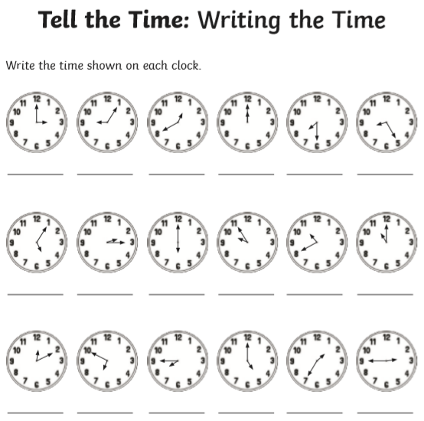
My answers are:

You can do this at home without showing the teacher unless your parents want to upload on to Google Classroom.
