Year 2 Measurement - Maths Day 3 15.7.2020
Please look through the powerpoint (from yesterday) to help you before you start these questions. Remember that you may need to use resources or paper to help you work out some of the answers.
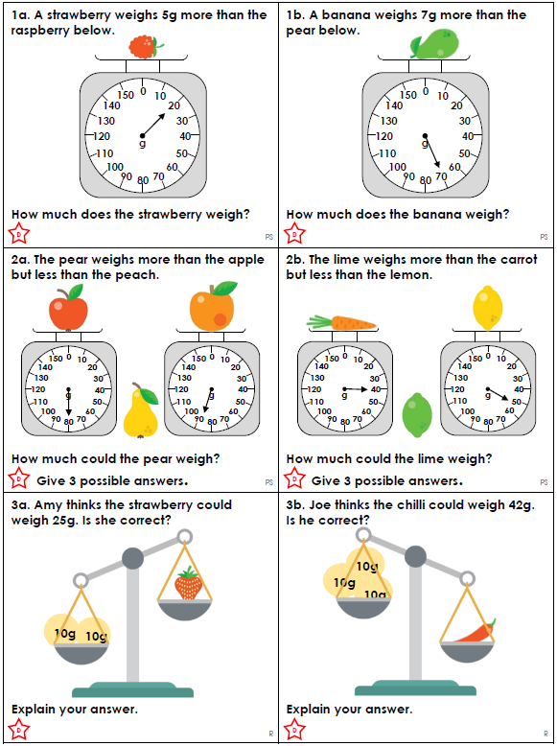
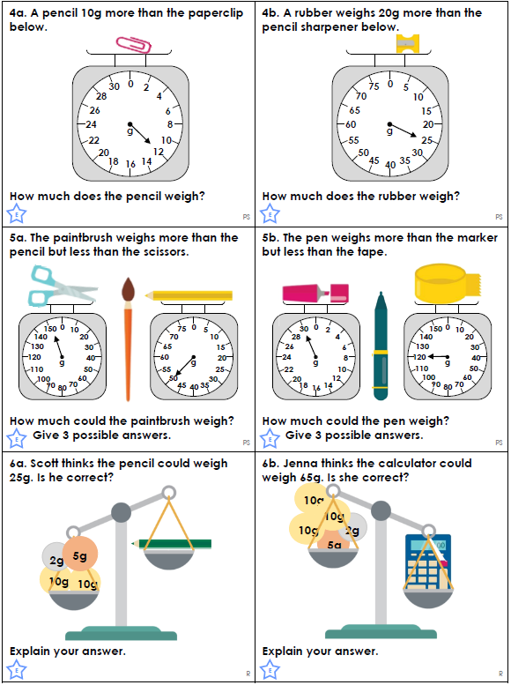
Remember the GD (gold star) questions are hardest questions so only complete them if you are confident you understand the learning.
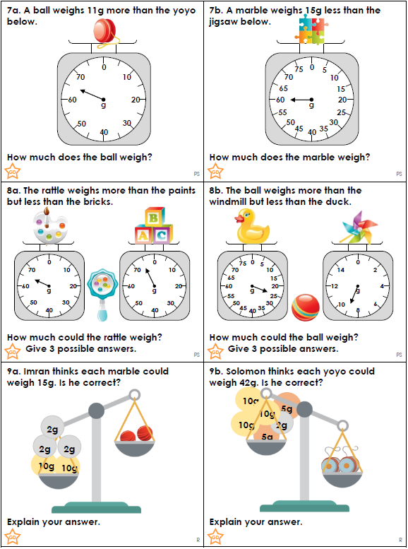
Answers: On the next page so please DO NOT look until you have finished your work first.
