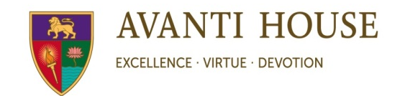

July 2020
Dear Reception Parents and Carers,

We would like to extend a warm welcome to you all for the academic year 2020-21. We look forward to working with all the pupils and their families to help them continue to grow as individuals with good character as well as achieving academic excellence. We are sure it will be an exciting journey ahead for all concerned.

It takes time for them to adjust from the Reception class setting to the more formal teaching day of the National Curriculum, hence we will be working on ‘transitioning’ the children towards this.

For us to have a great start to the year, we would like to provide you with some useful information to look at over the summer. There are links provided as well as the key learning resources we will be referring to over the next academic year.

Please use these to keep your children engaged in their learning activities to help them with a smoother transition when they come in September.

Phonics

Phonics is the fundamental way of teaching children to read quickly and skillfully. It is essential that you support your child in phonics as it is an essential part of your child’s development in reading and writing. We will be sending information through the year on how you can support your child in this area. Please use the information provided to help as well as the links on the school’s website.

Over the holidays, it would be beneficial for both the children and yourself to look through the links below to become familiar with the sounds we will be working on throughout the year in our run up to the Phonics screening check in summer next year!

https://avanti.org.uk/avantihouse-primary/pupils/reading-and-phonics/

https://avanti.org.uk/avantihouse-primary/reading/

https://avanti.org.uk/avantihouse-primary/phonics/

Reading

Reading is an essential part of children’s learning across all subjects. However, understanding what is being read is even more important. We will be using ‘Reading Dogs’ to assist the children with their comprehension. The ‘Reading Dogs’ are:

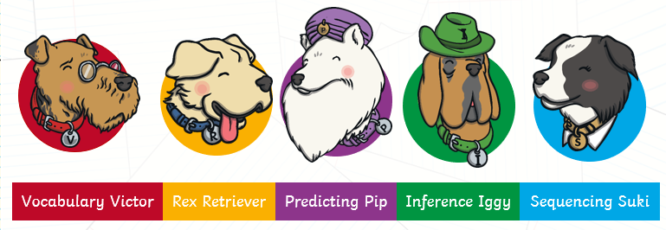

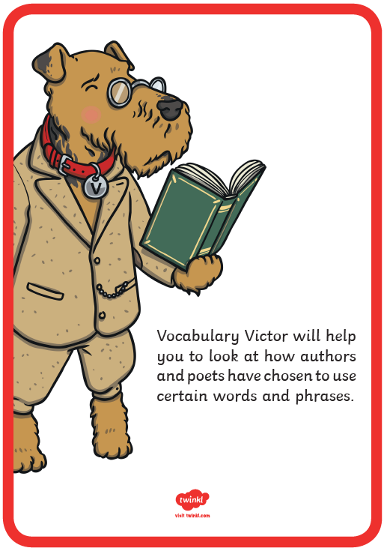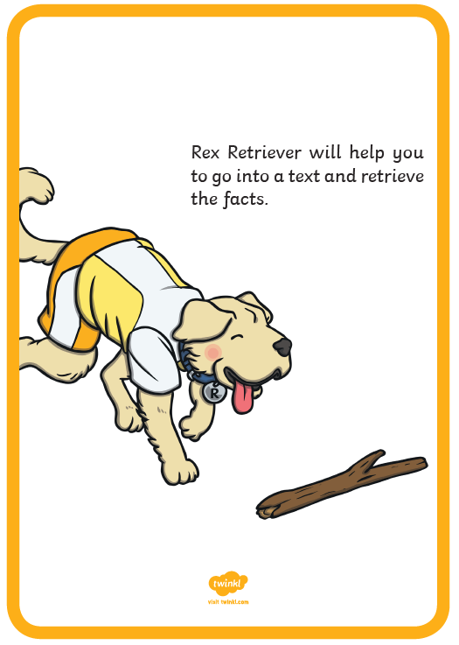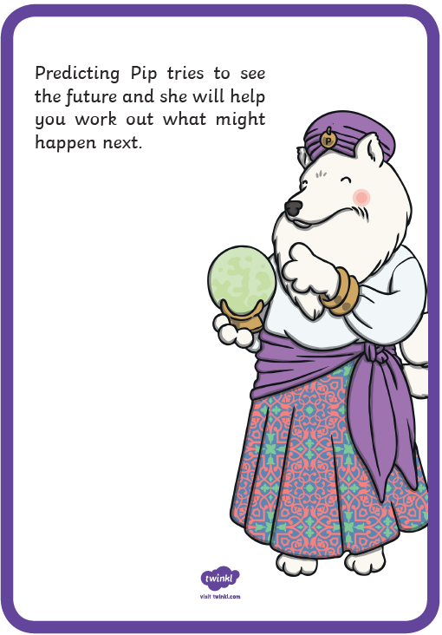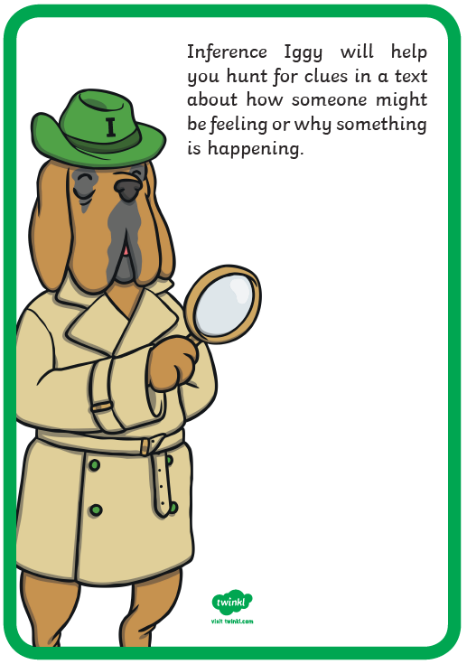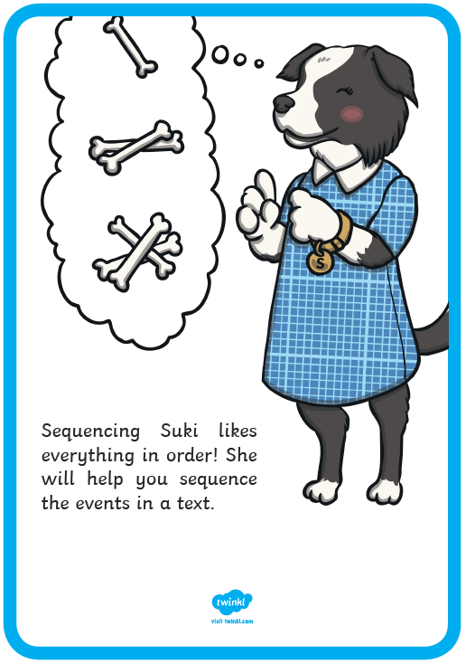

Each ‘dog’ focuses on different aspects of reading and understanding. The activities and homework we will set will focus on one or more of these aspect of reading in our attempt to make your child a holistic reader. You will receive more information about these in the new academic year.

We have sent you a document titled ‘Year 1 Questions for Reading Bookmark Question Cards’. Please print these, stick them back to back, laminate or cover them and use them as a bookmark whilst reading with your children.

Key Learning Resources

Please use the resources over the next few pages to help your child to familiarise themselves with numbers, sounds and words we will be focusing on in year 1. We notice many children are incorrectly forming some letters (such as ‘b’ , ‘d’ , ‘q’) particularly when writing their names, and some numbers as well (such as ‘3’ , ‘2’ , ‘5’ , ‘6’ , ‘7’ , ‘9’). These resources are an attempt to give the children a head start over the summer as they prepare for year 1.

Thank you for your cooperation and support. We look forward to meeting you in the new academic year.
Warm Regards,
Year 1 Team

100 Square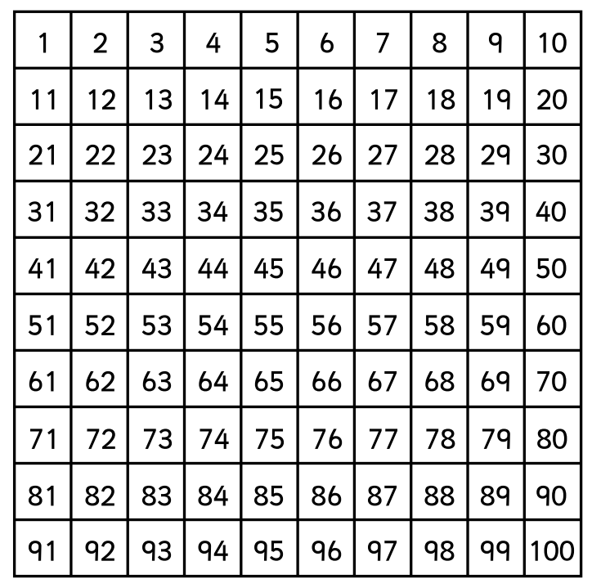

Phonic Sounds

All children have been taught these sounds in Reception, however, it is natural over the summer holiday the children may forget so practising them over the holiday period is helpful for their development. It is crucial they remember these sounds as it is the basis of their reading and writing/spelling. The children are encouraged to write words containing the Phase 2,3 and 5 sounds. We will also work on them at school in our daily phonic lessons. We will move onto Phase 5 and beyond (for most of the children) in the second half of the Autumn term.
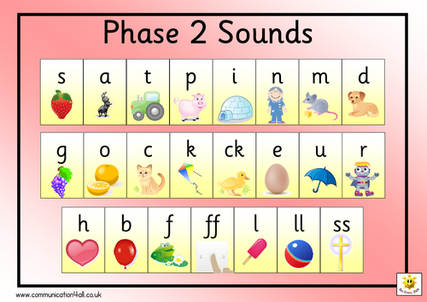

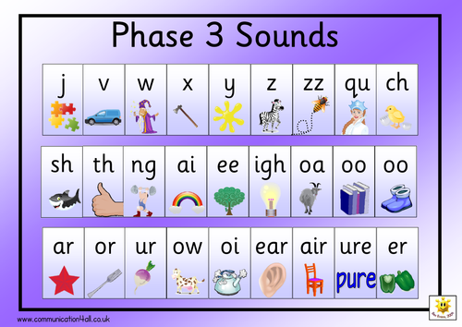

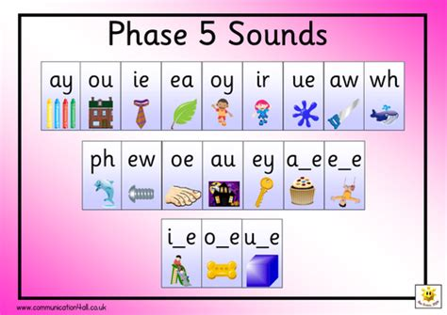

Common Exception Words - Children should know how to read and spell these words. They can practice writing simple sentences using these words and reading it back to check they make sense:

