Maths Homework - Year 3 (Due Wednesday 14th October)
This week we have been looking at 3 digit numbers, mental methods of subtracting and adding ones kepping within tens and crossing tens. Children have been introduced to the terms ‘regrouping’ and exchange’.
Do as many questions as you can 😊
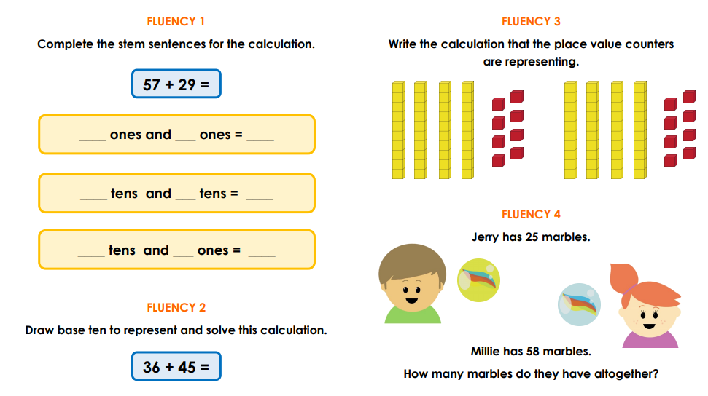

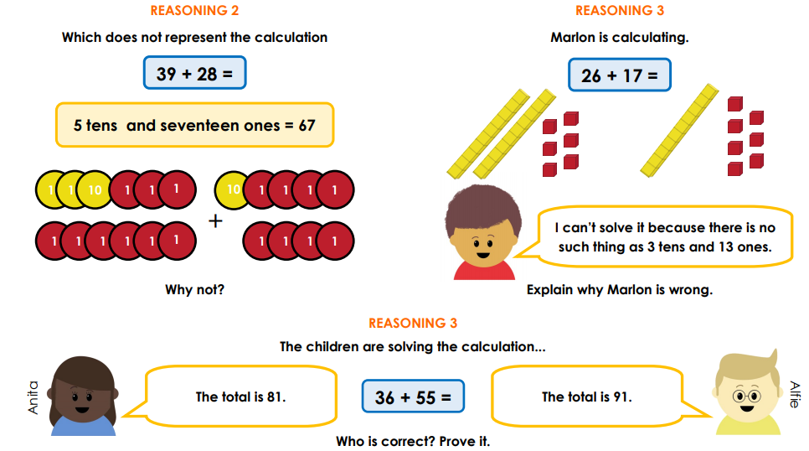

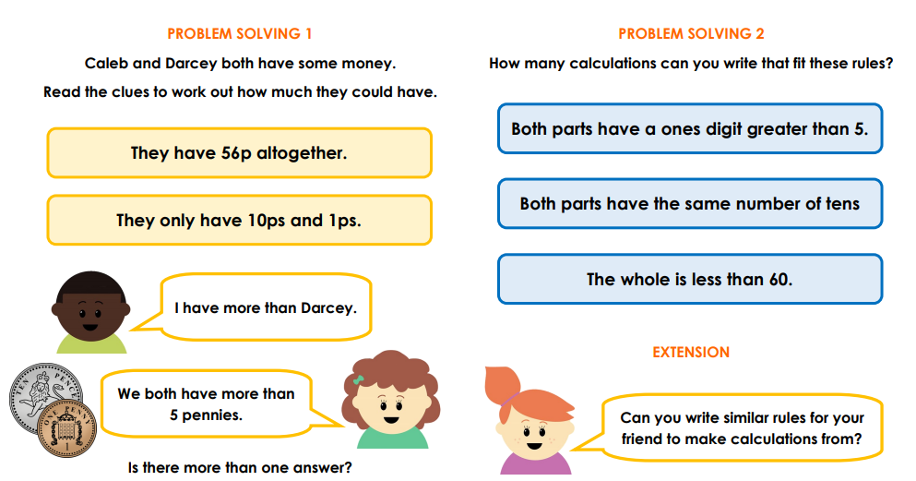

Times tables: it is important that you practice your times tables regularly?
Test yourself on the 3, 4 and 8 times tables, can you beat your own time?

Maths is everywhere!

