Maths Homework - Year 3 (Due Wednesday 22nd September)
This week we have been looking at 10 more and 10 less than any given number, practicing writing numbers as words and looking at placing numbers on a number line.
Place Value: Making 3 digit numbers

Using each digit card, which numbers can you make?
You can use the place value grid to help.
Hundreds | Tens | Ones

Numbers as Words
Write the following numbers as words.
Remember to check your spelling, use and if necessary and also practice saying the numbers aloud.
Example: 127 = one hundred and twenty seven
a) 87 b) 107 c) 342
d) 211 e) 690 f) 444
Hot Challenge
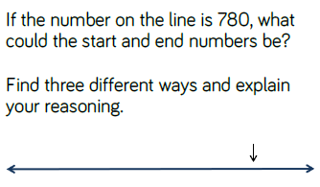
Next week we will be comparing objects and number.
Maths is everywhere! J

