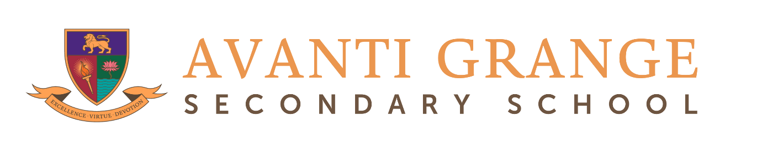

**Curriculum Map**

**Subject: Art and Design**

The Avanti Grange Art curriculum is designed to encourage and celebrate students as independent artists while providing them with the skills and knowledge required to fulfil their artistic aspirations. Students are encouraged to think and behave as artists from their first lesson in the studio. They develop a rich understanding of the purpose of an artist’s work and the history of art throughout humanity so that they are prepared to shape the future of artistic dialogue once leaving school. The KS3 themes are designed around major genres in Art such as landscape, still life and portraiture to provide a broad, far-reaching overview of Art history and provoke enquiry into the same questions that artists have been grappling with for centuries. Students are able to produce a myriad of personal creative responses in a diverse range of media. Each year culminates in a student-led project that reflects on the theme studied in order that students are well prepared for the independent nature of the KS4 and KS5 curriculums.

Students are encouraged to stretch and explore a wide variety of drawing and painting materials, print making and sculpture techniques including ceramics, textile and fibre arts and digital mediums such as photography. Inventive experimentation is the cornerstone of the curriculum, but students are supported in their artistic decision making by the acquisition and development of key skills, vocabulary and technical theory.

Studying Art at Avanti Grange equips students with skills and experiences that extend beyond the art studio. The curriculum not only nurtures their artistic talents but also prepares them for a variety of future pathways. Students develop critical thinking, problem-solving abilities, and creative expression, which are valuable in many fields. The curriculum is aimed at building confidence, fostering independent thought, and preparing students for further education and careers in the arts, as well as contributing positively to their personal growth and understanding of the world around them.

|  |  |  |  |  |  |  |
| --- | --- | --- | --- | --- | --- | --- |
| **Year Group** | **Autumn Half Term 1** | **Autumn Half Term 2** | **Spring Half Term 1** | **Spring Half Term 2** | **Summer Half Term 1** | **Summer Half Term 2** |
| **Key Stage 3** | | | | | | |
| **7**  **ENVIRONMENTS – how do artists respond to and make work about the world around them?** | **Introduction to art:**  What is art? What do artists do? How can I be an effective artist? **Typography and Presentation:**  How do artists communicate effectively?  Drawing and presentation skills looking at the work of graphic designer Paula Scher and medieval illuminated manuscripts | **Environments – Pathway 1: Sea and Sky**  An introduction to observational drawing using mixed media to record observations of natural objects. | **Environments – Pathway 1: Sea and Sky**  Animal composition using a variety of painting materials and wax resist techniques including Indian ink, watercolours and oil pastels.  Introduction to collage using hand drawn papers | **Environments – Pathway 2: Destinations**  A comparison of how the theme of landscape has been considered in Western and Eastern painting traditions.  Chinese landscape scroll painting using Indian ink.  Independent landscape compositions inspired by a range of artists both historic and contemporary | **Environments – Pathway 2: Destinations**  Independent landscape composition and an introduction to colour theory using acrylic paints | **Environments – Pathway 3: Plant life**  Large scale drawing and painting  **Environments – Independent Project**  A personal response to the theme using a choice of drawing and painting media |
| **8**  **OBJECTS AND ARTEFACTS – how do artists manipulate materials and imbue the objects they have created with meaning?** | **Objects and Artefacts – Pathway 1: Still Life**  Focus on the formal elements – form and tone  Drawing still life objects such as fruit, flowers and vessels | **Objects and Artefacts – Pathway 1: Still Life**  Large scale acrylic still life compositions inspired by the work of artists such as Arcimboldo and Yayoi Kusama | **Objects and Artefacts – Pathway 2: Symbolic objects in Art and memento mori**  Introduction to the concept of memento mori from Egyptian shabti, to 17th century Dutch still life, Damien Hirst and local contemporary artist Aine Corr  Pastel drawing and printmaking | **Objects and Artefacts – Pathway 2: Symbolic objects in Art and memento mori**  Multi-media personal memento mori project inspired by music using paint, collage and printmaking. | **Objects and Artefacts – Pathway 3: Surrealism**  Found object sculpture looking at the work of Oldenburg and Dali | **Objects and Artefacts - Independent Project**  A personal response to the theme using a choice of media |
| **9**  **IDENTITY – how do artists discover, express and reflect on identity?** | **Identity – Pathway 1: Portraiture**  Drawing and painting mixed media portraits | **Identity – Pathway 1: Portraiture**  Portraits in clay using slab and coil techniques | **Identity – Pathway 1: Portraiture**  Portraits in clay using slab and coil techniques | **Identity – Pathway 2: Heritage and Rituals**  Mask making sculpture | **Identity – Pathway 2: Heritage and Rituals**  Textile work looking at the history and significance of quilt making to identity | **Identity – Independent Project**  A personal response to the theme using a choice of media |

|  |  |  |  |  |  |  |
| --- | --- | --- | --- | --- | --- | --- |
| **Key Stage 4 (GCSE)** | | | | | | |
| **10** |  |  |  |  |  |  |
| **11** |  |  |  |  |  |  |
| **Key Stage 5 (A level)** | | | | | | |
| **12** |  |  |  |  |  |  |
| **13** |  |  |  |  |  |  |