**ee/ai/oa/igh**

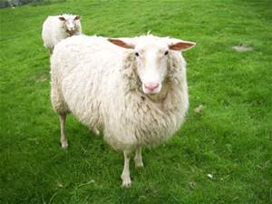 

|  |  |  |
| --- | --- | --- |
|  |  |  |

|  |  |  |
| --- | --- | --- |
|  |  |  |

|  |  |  |
| --- | --- | --- |
|  |  |  |

 

|  |  |  |
| --- | --- | --- |
|  |  |  |

**ar/or/ow**

 

|  |  |
| --- | --- |
|  |  |

|  |  |
| --- | --- |
|  |  |

|  |  |  |
| --- | --- | --- |
|  |  |  |



**Practise using phone frames to label pictures. See if you can write sentences using the words**

**Sh/ch/ng/th**

|  |  |  |  |  |
| --- | --- | --- | --- | --- |
|  |  |  |  |  |

 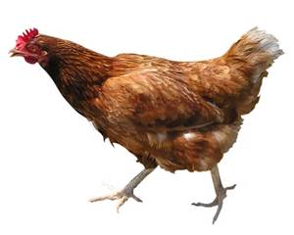

|  |  |  |
| --- | --- | --- |
|  |  |  |

|  |  |  |  |
| --- | --- | --- | --- |
|  |  |  |  |

[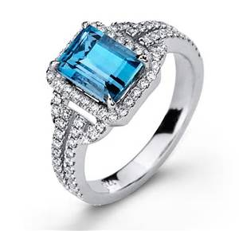](https://uk.images.search.yahoo.com/images/view;_ylt=A2KLj9FQdrdWNkUAUbOe3olQ;_ylu=X3oDMTIzamxhYXY0BHNlYwNzcgRzbGsDaW1nBG9pZANkYjM1NjZiMGQzZjkxYTI1OTNjOWQxNjE4ODYzZjI4MQRncG9zAzE1BGl0A2Jpbmc-?.origin=&back=https%3A%2F%2Fuk.images.search.yahoo.com%2Fyhs%2Fsearch%3Fp%3Dring%26n%3D60%26ei%3DUTF-8%26fr%3Dyhs-ushi-001%26fr2%3Dsb-top-uk.images.search.yahoo.com%26hsimp%3Dyhs-001%26hspart%3Dushi%26tab%3Dorganic%26ri%3D15&w=1041&h=1006&imgurl=kaos.web44.net%2Fwp-content%2Fuploads%2F2012%2F05%2Fdiamond-rings.jpg&rurl=http%3A%2F%2Fkaos.web44.net%2Fdiamond-rings&size=144.3KB&name=diamond+rings&p=ring&oid=db3566b0d3f91a2593c9d1618863f281&fr2=sb-top-uk.images.search.yahoo.com&fr=yhs-ushi-001&tt=diamond+rings&b=0&ni=108&no=15&ts=&tab=organic&sigr=113ncaum8&sigb=1548forc3&sigi=11rh29c6q&sigt=10d22h9ms&sign=10d22h9ms&.crumb=GsT.Q2mbgoI&fr=yhs-ushi-001&fr2=sb-top-uk.images.search.yahoo.com&hsimp=yhs-001&hspart=ushi) 

      
      
      