Krishna Avanti Harrow achieves London Healthy Schools Gold Award!
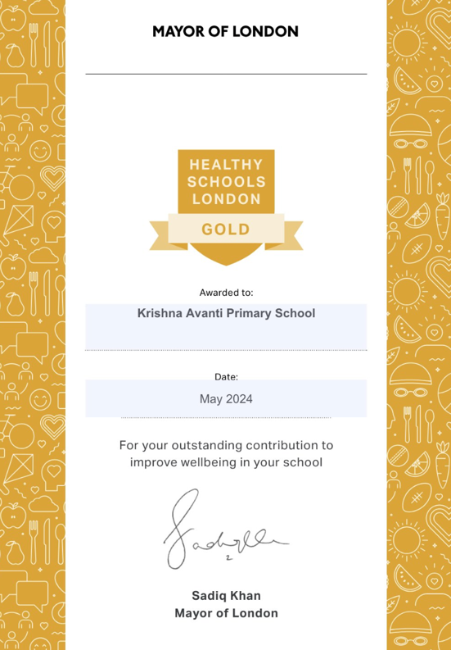
KAPSH has earned the Healthy Schools London Gold Award (summer 2024)!
Since 2022, we have been planning and rolling out new initiatives to support all children across the school with their mental health. Pupils were given opportunities to share their thoughts during surveys and discussions, which formed the foundation of our areas of focus.

The Well-being Warriors (peer support group) reflected upon the purpose of each initiative:
- Well-being Warriors – Children across KS2 had the opportunity to apply for this role. They were then carefully selected by their class teachers. Our Well-being Warriors provide peer support and often, children reach out to them. They are currently being trained to recognise the signs of poor mental health themselves.
- Playground Games – Teachers are leading and joining in with games during break and lunch duties. This creates an inclusive environment as all children are invited to play.
- Worry Box – Each class has a Worry Box and children fill out worry slips, which the teachers check daily. The teachers then check in with the children individually.
- Bags of Happiness – The Molly Rose Foundation supported our school with a fantastic activity as well as resources, to create our own bags of all the things that make us happy.
- Mental Health Newsletter – Mrs Pindolia and the Well-being Warriors put a termly newsletter together, updating our parents about all our wonderful mental health enrichments and tips to help both children and parents
- Mental Health Awareness – As well as explicitly teaching children about mental health through our PSHE curriculum, we also have fantastic enrichment opportunities such as Anti-Bullying Day, World Mental Health Day and Children’s Mental Health Week.
Our journey with improving children’s mental health has not stopped, as we continue to embark on a new project, which is designed and supported by a company called One Goal. We have thirty Well-being Warriors across the school and they are currently participating in weekly training sessions so that they are equipped with the skills they need to support their own and others’ mental health.

